INTE 12213– Object Oriented Programming

Lab Exercises 04

* You are given the following tasks. Perform all of them.
* You have to use a text editor and the terminal in order to complete the below tasks and you are not permitted to use an IDE.
* Prepare a report with the experiment, your observations on each task and conclusions. Submit the files by Saturday 07th, Nov 11.59 pm
* No marks will be given to any late submissions.
* (Try to use Linux environment)

------------------------------------------------------------------------------------------------------------------------------------------

# Lab04_Task01

Write an application that uses only the output statements

System.out.print( "* " );

System.out.print( " " ); System.out.println(); to display in the command window, the checkerboard pattern that follows:

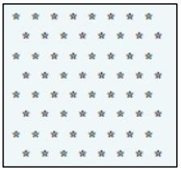

Hints:

* Note that println with no arguments outputs a newline.
* A nested repetition statement is required in this exercise.

# Lab04_Task02

Write an application that evaluates the factorials of the integers from 1 to 5. Display the results in tabular format.

Hints:

* Use nested for loops in this exercise.
* The inner for loop should compute the factorial.

Your output should appear as follows:

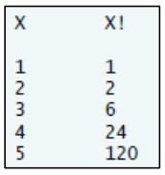

# Lab04_Task03

Create a class called Date that includes three pieces of information as instance variables—a month (type int), a day (type int) and a year (type int). Your class should have a constructor that initializes the three instance variables and assumes that the values provided are correct. Provide a set and a get method for each instance variable. Provide a method displayDate that displays the month, day and year separated by forward slashes (/). Write a test application named DateTest that demonstrates class Date’s capabilities.

Hints:

* For the purpose of this chapter, it is not necessary to validate the values passed to the constructor or the set methods.
* Your output should appear as follows:



# Lab04_Task04

# Create a class Rectangle. The class has attributes length and width, each of which defaults to 1. Provide methods that calculate the perimeter and the area of the rectangle. Provide set and get methods for both length and width. The set methods should verify that length and width are each floating-point numbers greater than or equal to 0.0 and less than 20.0. Write a program to test class Rectangle.

Hints:

* Your output should appear as follows:

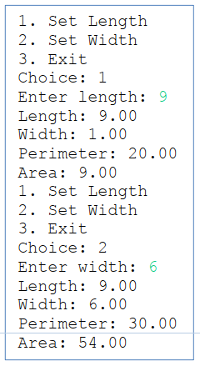

# Lab04_Task05

Write the class declaration for class Square that has a private instance variable side of type double and a no-argument constructor that sets the side to 1.0 by calling a method named setSide. Also make sure that the side is not less than 0.0. If it is, keep the default setting of 1.0.

Write a method getSide for the class that retrieves the value of instance variable side. Then Define another constructor for that takes one argument, the side, and uses the Square’s set method to set the side.

Write a method computeArea for the class that computes the area of a Square. Define application class SquareTest to test the Square class.

# Lab04_Task06

Write an inheritance hierarchy for classes Quadrilateral, Trapezoid, Parallelogram, Rectangle and Square. Use Quadrilateral as the superclass of the hierarchy. Specify the instance variables and methods for each class. The private instance variables of Quadrilateral should be the x-y coordinate pairs for the four endpoints of the Quadrilateral. Write a program that instantiates objects of your classes and outputs each object’s area (except Quadrilateral).

Hints:

* Create and use a Point class to represent the corners of the shapes.
* Your output should appear as follows:

